Instructions for BADE Task

Before You Begin: Because this is a Java based app, you need the Java Runtime Environment (JRE) installed on your computer. You can find the latest version to download here:
http://www.oracle.com/technetwork/java/javase/downloads/jre8-downloads-2133155.html

There are multiple platforms that you can download the JRE for, which means you will be able to run the BADE jar on any of these platforms.

In order to determine which version of Java you need to verify if you are using 32-bit or 64-bit browser:
- Internet Explorer:
- Launch Internet Explorer browser.
- Click on the Help tab at the top.
- Select About Internet Explorer which will bring up an information window.
If the version of IE displays 64-bit Edition, then it is 64-bit IE, otherwise it is a 32-bit browser.
- Firefox:
To determine whether you are running on a 64-bit version of Firefox, use either of these methods.
- Check the About Firefox panel
- Type in the browser address about:support
If you are running 64-bit Firefox, it may be indicated as 64-bit (e.g., Win64), otherwise it is a 32-bit version of Firefox.
- How to determine if Windows OS is 32-bit (x86) or 64-bit (x64):
If a PC has more than 4 GB of RAM installed, it most likely is using the 64-bit version of Windows.
Do a search in the finder for system type and then click on System Information. In the System Information panel, you will find an item called System Type which will tell you if your OS if 32-bit or 64-bit.
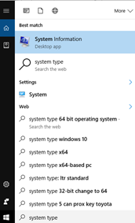
Figure 0.1: Finding the system type for your operating system.

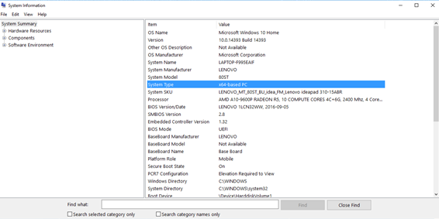
Figure 0.2: Finding the system type for your operating system.

IMPORTANT:

The software, BADE.jar, calls a specific file, config_task.txt, which must be named accordingly. The software will not work if the configuration file is named as anything other than config_task.txt.

After downloading the necessary files, move BADE.jar and config_practice.txt to another folder (e.g. /practice). Also move config_task.txt and a copy of BADE.jar to another separate folder (e.g. /task). Rename both config_practice.txt and config_task.txt to config_task.txt in their respective folders.

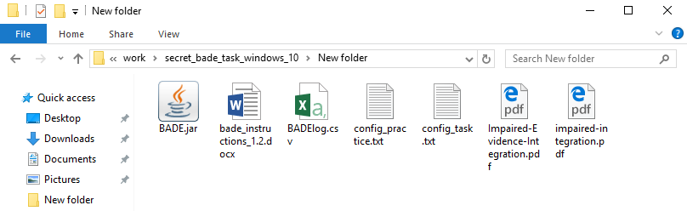

Figure 1: Files included in BADE package

INTRODUCTION:

(For a more detailed introduction, please refer to the two papers included in the download package).

In the BADE task, participants are required to rate the plausibility of four interpretations of a scenario three times. Three sequential ratings of each interpretation are required as participants are exposed to new evidence about the scenario interpretation after the presentation of each scenario statements. Two of the interpretations are initially plausible explanations that later require revision, and are referred to as lures. One is an option that is highly implausible from the outset and remains so, and is referred to as an absurd interpretation. Finally, one is initially moderately plausible, but gradually become the most plausible, and is referred to as a true interpretation. Participants’ willingness to adjust their plausibility ratings for the scenario interpretations as disambiguating evidence accumulates over the three statement presentations is measured.

PRACTICE TRAINING:

Prior to reading the instructions to the participant, open the practice trial (by running the BADE.jar file you have moved into your practice folder) so that the participant can visually see the experimental set up, understand what is meant by sentence (one of the four possible interpretations) versus hint (one of the three lures) and see the layout of the sentences and hints. Enter a participant number and click Begin (there is only one scenario in the practice, so it is not necessary to define the task trials to run sequentially or randomly).

The experimenter can follow the instruction script as outlined in the following section of this manual for both the practice and applied task to aid in explaining the task to the participant.

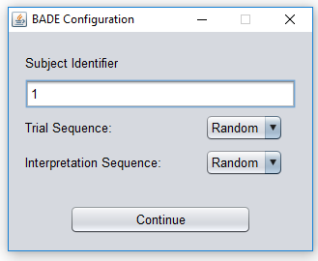
Figure 2: Setup screen

You can let the participant try out the ratings in the practice round by showing them how to do the first set of ratings after hint #1 (if possible try to get the participant’s opinion with these first ratings). Then encourage the participant to do the ratings on their own after hint 2 and 3.

Note: the practice round is unique from the other scenarios in the actual study because it has 2 lures, and 2 true statements (instead of two lures, one absurd, and one true statement).

At this time, make sure the participant is comfortable using the scroll bars and/or has had enough practice to start the true experiment.

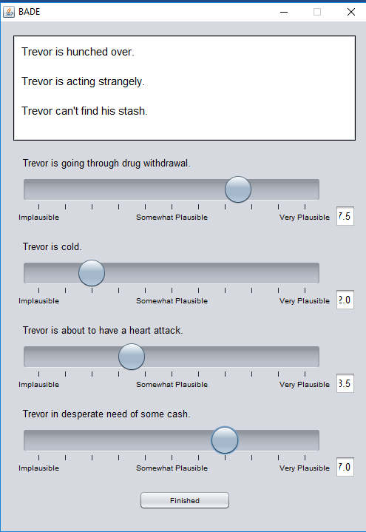
Hints
Sentences

Figure 3: Task screen displaying three hints and rated four sentences.

TO RUN THE EXPERIMENT:

Ensure you have the necessary html files in your folder (BADE.jar and config_task.txt). Double click on the BADE.jar file in the appropriate folder, and this will start the experiment (the first four sentences with scroll bars, plus the first hint will be displayed on the screen). Enter the participant number and change Trial Sequence and Interpretation Sequence to “Random” (unless you want to run the trials in the sequence they are listed in the config_task.txt file).

Experimenter says:

“You will see four sentences on a screen, and each sentence will have its own scroll bar or scale. I would like you to use these scroll bars to rate the plausibility of each sentence after you have been given a specific hint (shown at the top of the screen). In other words, I would like you to rate how well each of the four sentences relate to and/or are a good responses to the given hints (ratings are on a scale from 0 to 10 and these numbers are displayed in a box to the right of each sentence). The scale has some words to remind you what each end, or rating, of the scale represents; for example the scale ranges from an implausible sentence at the left end of the scale, to a somewhat plausible sentence in the middle of the scale, and a very plausible sentence at the right end of the scale. You can make your rating anywhere along the scale besides at these three points.

Before you start, I would like you to be aware that you will be given 3 hints in total, and each hint gives you a little more information than the previous one, to create a mini story. With each hint, you will be asked to change your ratings as you are given more information. You may change your mind or score for each sentence as little or as much as you like, and one or more of the ratings can be the same if you feel that they have equal plausibility. Or you may feel that you would like to keep some of the ratings unchanged after being given the new hint. ***BUT PLEASE NOTE that each of the four sentences should be rated independently from one another. In other words, don’t compare the four sentences to one another; instead rate how well they relate to the hints on their own. It is possible that none or many of the sentences will provide a good fit to the hint. Any questions before we start? When you are finished making your ratings, press ‘Next’ to move on to the next hint. After you have made ratings for all three hints, press ‘Finished’ to move on to the next scenario.”

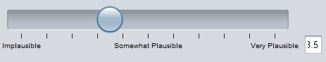

Figure 4: A rating scroll bar displaying numeric rating displayed in rightmost box.

Data will be saved to a file called BADElog.csv. This file will be created after the first run of the task and new data will be appended with each successive run. Each set of data will begin with the participant number in one row, followed by the date and time of task completion in the next row, and then the recorded data (as outlined below).

Note that the participant must complete the task in order for the data to be saved. If the participant does not want to complete the task, ensure you have continued through all trials before closing the window. You can remove these incomplete trials from the BADElog.csv file afterwards.

Recorded data:

trial: Refers to the scenario as organized in the config_task.txt file.
trial_type: Indicates if the trial was Emotional, Neutral, or a Distractor.
stmnt_type: Statement type indicates the first (1), second (2), or third (3)
sentence being rated. Note that no difference between
statement types has been confirmed.
int_num: Interpretation number refers to the sentence being rated:

Sentence 1: Neutral Lure
Sentence 2: Emotional Lure
Sentence 3: Absurd
Sentence 4: Truth

int_type: Interpretation type is the text description associated with
int_num.
rating: Refers to the rating made by the participant for each hint and
sentence in each scenario

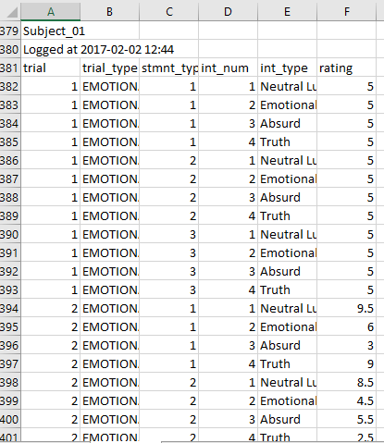

Figure 6: Excerpt from a BADE logfile (for participant Subject_01).

Scoring of BADE Task

Note: Each scenario condition name (e.g. emotional, neutral, or distractor) is listed in the config_task.txt file; scenarios 1-12 are emotional, scenarios 13-24 are neutral, and scenarios 25-30 are distractor. As well, the config_task.txt file is ordered such that the first sentence is a neutral lure, the second sentence is an emotional lure, the third sentence is absurd, and the fourth sentence is true (see “int_num” described above).

Current scoring of the BADE task involves consideration of two components: ‘evidence integration’ (the degree to which disambiguating information has been integrated) and ‘conservatism’ (reduced willingness to provide high plausibility ratings when justified). Only evidence integration differs between severely delusional patients and the other groups, reflecting delusional subjects giving higher ratings for disconfirmed interpretations and lower ratings for confirmed interpretations.

For comparisons across studies, evidence integration and conservatism should be computed as sums of their respective indicators. Item scores need to be converted to Z scores prior to summing (mean of 0 STD of 1, which is achieved by subtracting out the variable mean and dividing each value by the variables’ standard deviation). Specifically, we recommend that after conversion to Z scores, evidence integration be computed as the sum of absurd 1, absurd 2, absurd 3, neutral lure 3, emotional lure 3, and (true 3 ×−1), and that conservatism be computed as the sum of neutral lure 1, neutral lure 2, emotional lure 1, emotional lure 2, true 1, and true 2.

- For a complete description of PCA analysis and scoring methods, please see Sanford, N., Veckenstedt, R., Moritz, S., Balzan, R.P., & Woodward, T.S. (2014). Impaired integration of disambiguating evidence in delusional schizophrenia patients. Psychological Medicine, 44(13), 2729-2738.

Note particularly in the paper above, the section described “Comparisons with previous studies” (p.2735) which describes in more detail scoring methods.

